………… ANATOLIAN HIGH SCHOOL Yazilidayim.net ACADEMIC YEAR 1st TERM 1st ENGLISH PRACTICE EXAM for 9-A

Full Name: Class – Number:

READING (25 PTS)

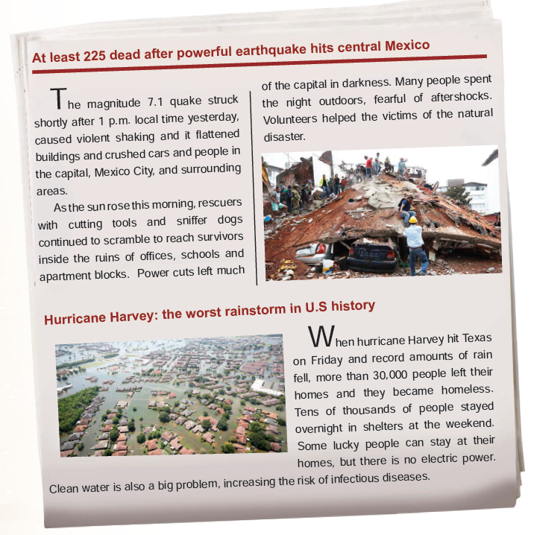

A)Read the newspaper extacts and answer the questions? (6x3=18 pts)

1)What time did the eathquake struck?

2) What did the eathquake cause?

3)What left much of the capital in darkness?

4)Where did many peaple spend the night?

5) Why did more than 30,000 people become homeless?

6) What kind of problems do victims have after a disaster?

C) Write Turkish meanings of words the below (7x1=7pts)

magnitude: flatter: cause:

hurricane: victim: homeless:

increase:

WRITING (25 PTS)

A)“What can you do?” Write 5 sentences. (I can ..swim...) 5pts

1.
2.
3.
4.
5.

B) “What do you do in your free time?” Write 10 sentences. (I ..watch films..) 10pts

1.

2.

3.

4.

5.

6.

7.

8.

9.

10.

C)What does your friend do in her/his free time? ( He/She ..plays..guitar..) 10 pts

1.

2.

3.

4.

5.

6.

7.

8.

9.

10.

LISTENING (25 PTS)
A)Listen Gale and Jackie and answer the questions.(10x2,5=25pts)

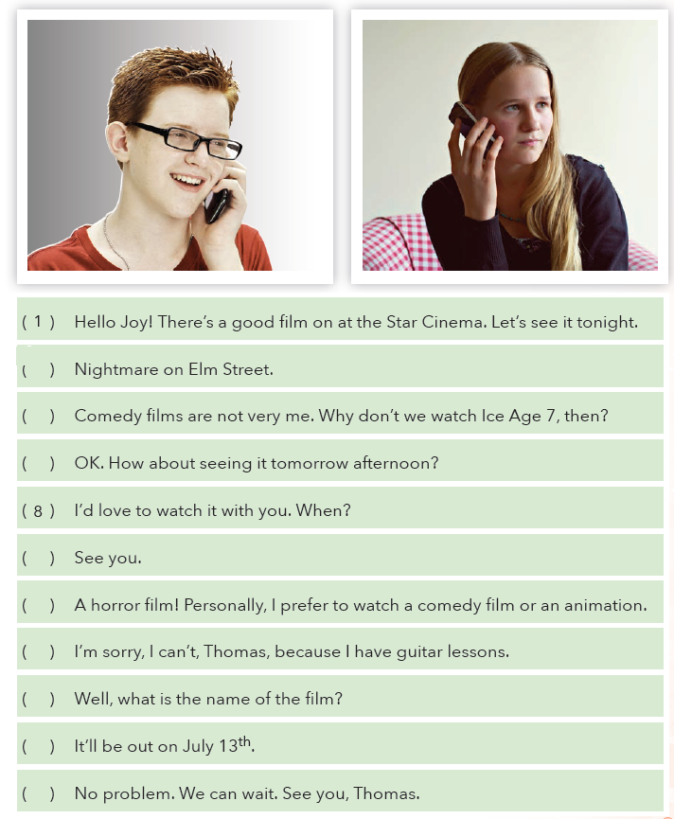

SPEAKING (25 pts)

Topic:

Speaking Evaluation Chart

Content | 0 | 1 | 2 | 3 | 4 | 5
Pronunciation | 0 | 1 | 2 | 3 | 4 | 5
Fluency | 0 | 1 | 2 | 3 | 4 | 5
Accuracy | 0 | 1 | 2 | 3 | 4 | 5
Vocabulary | 0 | 1 | 2 | 3 | 4 | 5

GOOD LUCK
English Language Teacher

